EFUDIX CREAM PATIENT INFORMATION SHEET
Sonning Common Health Centre

What is Efudix®?
Efudix® cream is a treatment that selectively destroys sun-damaged cells in the skin whilst retaining the normal healthy skin cells. The active ingredient is 5% 5-fluorouracil.

What do we use it for?
Efudix is prescribed for the treatment of the pre-cancerous skin lesions, actinic keratoses and Bowen’s disease. It is also used for the treatment of superficial basal cell carcinoma. It is sometimes used to treat other skin conditions such as viral warts, and rarer conditions such as disseminated superficial actinic porokeratosis.

Skin reaction - What to expect
During treatment, the area of your skin that have sunspots will look and feel irritated. Some people have a mild reaction, others a severe reaction. The redness, inflammation, irritation, crusting and peeling you see are signs of efudix working to eliminate the abnormal cells (Picture 1 and Picture 2). While this stage of treatment might be unattractive and uncomfortable, it is important that you do not stop the treatment without checking with your GP first. You may notice redness and inflammation in nearby areas of skin that did not appear to have any abnormalities. This is because of the invisible abnormal cells in your skin. If you have many abnormal cells and lesions you can expect to develop more redness and inflammation than a person who has a single area of abnormality. This reaction will settle over a few weeks. Sometimes your doctor may recommend using a steroid cream to help settle the inflammation more quickly.
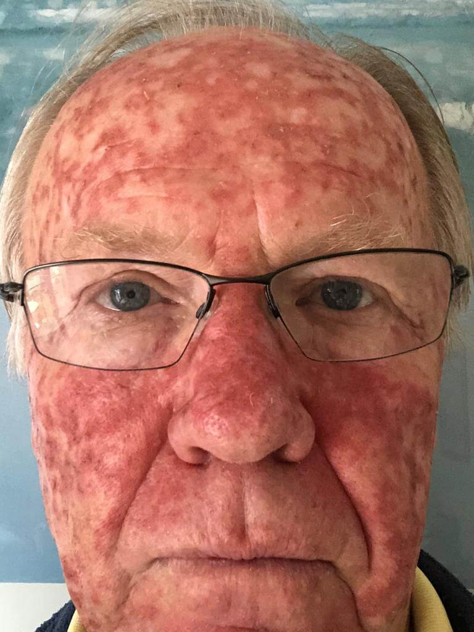
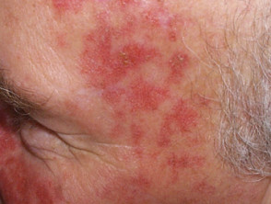

(Picture 1 – Normal skin reaction) (Picture 2 – Normal skin reaction 2 weeks after treatment)

Does it always work?
Efudix may cure or improve your condition, but it does not work for everybody. If you have more severe sun-damage, you may require additional courses of treatment.

How do I apply it?
Efudix cream can be applied with a clean fingertip. Apply a thin layer of the cream to the entire treatment area. You should wash your hands thoroughly after applying the cream. After 20 minutes, you can apply moisturisers and/or make-up as part of your usual skin care routine. If you have widespread sun-damage it is usually advisable to divide the affected area into smaller areas and to complete treatment in one area before moving on to the next. This will help make the treatment reaction more tolerable but if in doubt get advice from your doctor.

How often should I use it?
How often and for how long you should use efudix cream will depend on your skin condition and other factors, for example which part of your skin is affected. The cream is usually applied once or twice a day, for 3-4 weeks when treating actinic keratosis and Bowen’s disease, and for 6 weeks when treating superficial basal cell carcinoma. Occasionally, more prolonged courses may be required. Your doctor will recommend a specific treatment schedule for you.

When should I not apply it?
Efudix should not be used around the eyes or lips, unless specifically recommended by your doctor for use in that area. Do not apply it if you are pregnant or breastfeeding or you are allergic to any of its ingredients.

What are the common side effects?
As mentioned above, inflammation of the skin is expected, but if the skin becomes very sore or uncomfortable, stop using it. Bathe the area with water, dab the skin dry and apply petroleum jelly daily. The petroleum jelly that you apply should be newly opened and free from potential contamination from fingertips. When the skin settles, you may be able to continue the cream to complete the treatment course. If you have any concerns about the severity of the treatment site reaction or are uncertain about whether you should continue treatment please let us know. Efudix makes your skin more sensitive to sunlight at the site of application, and therefore you should avoid significant sun exposure during and for a while after treatment. This may include modifying activities to limit sun exposure, wearing clothing/hat etc and the use of sunscreens.

What are the rare side effects?
If you have a severe reaction to efudix, there is a risk of prolonged inflammation and delayed healing and the potential for the development of an ulcer, particularly on the lower legs. Following a severe reaction, there is a small risk of altered skin pigmentation and scarring. Skin infections at the site of application of the cream are rare but possible. Very rarely, patients can be allergic it. This usually causes a severe localised skin reaction. If you have concerns about the severity of your reaction to it, get in touch with your doctor. Like all medications, efudix should be kept out of reach of children and pets.

Other reliable links for more information
https://www.bad.org.uk/shared/get-file.ashx?id=187&itemtype=document (this patient information sheet is based on this leaflet by the British Association of Dermatology that you can read here in full)
http://www.patient.co.uk/medicine/Fluorouracil-Cream.htm http://www.dermnetnz.org/treatments/5-fluorouracil.html

