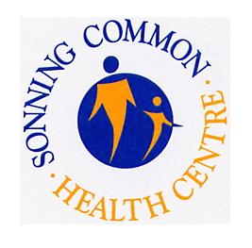
How we use your medical records
Important information for patients

- This practice handles medical records in-line with laws on data protection and confidentiality.

- We share medical records with those who are involved in providing you with care and treatment.

- In some circumstances we will also share medical records for medical research, for example to find out more about why people get ill.

- We share information when the law requires us to do so, for example, to prevent infectious diseases from spreading or to check the care being provided to you is safe.

- You have the right to be given a copy of your medical record.

- You have the right to object to your medical records being shared with those who provide you with care.

- You have the right to object to your information being used for medical research and to plan health services.

- You have the right to have any mistakes corrected and to complain to the Information Commissioner’s Office. Please see the practice privacy notice on the website or speak to a member of staff for more information about your rights.

- For more information please visit our website to read our privacy notice on the homepage at www.sonningcommonhealthcentre.co.uk

Reviewed and updated: July 2020

